How to connect and run the Lepton IR camera with a Raspberry Pi

1. Connect the Lepton to the RPi as in the diagram. Note that pins are stated on the lepton for connection.

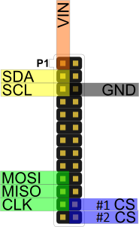

Regarding the CS pin. The programs say the CS pin (one of the 2) can be selected. The pin used by default from the next package is #1 CS. If this does not work, which the CS pin between the 2 until it does.

1. Download the git repository (<https://github.com/groupgets/pylepton.git>) to a desired location.
2. Follow the installation step at (<https://github.com/groupgets/pylepton>).
3. To simplify (in the terminal):
   1. sudo apt-get install python-opencv python-numpy
   2. sudo python setup.py install
4. After restarting, you can follow any of the examples in the above link. The first example can be placed into a python file (eg. Leptontest.py) and run via
   1. Python Leptontest.py
5. Running “a,_ = l.capture()” in a loop will continuously capture new images from the device. The rest is to save the data as an image.